BÀI ÔN TATC KHỐI 4 LẦN 2

(Week 22B-18/02/2021)

READING

**I/ Look and read. Choose the correct words and write them on the lines. There is one example.**

|  |  |  |  |  |
| --- | --- | --- | --- | --- |
|  |  |  |  |  |
| **kitchen** | **shopping mall** | **singer** | **bean sprouts** | **movie theater** |
|  |  |  |  |  |
| **museum** | **sauce** | **the countryside** | **football** | **the wind** |

1. This is where you eat your breakfast. kitchen
2. This is something outside that you can’t see, but it can move things like leaves on the trees.

.................................

1. This is where you can buy food or clothes. ……………………..
2. The place is outside the city. There are fields, trees, and animals

here.

……………………..

1. The person can sing very beautifully. ……………………..
2. The bean that has just started to grow and is eaten as a

vegetable.

……………………..

1. This is a game. People kick a ball around the field. ………………………
2. It’s a liquid eaten with food to add flavor. ………………………
3. You can watch a play or an opera in this place. …………………….
4. This building where people can see many historical objects. …………………….

**II/ Read a story. Choose the word from the box. Write the correct word to number 1-6. There is one example.**

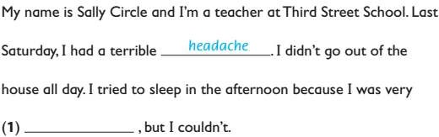

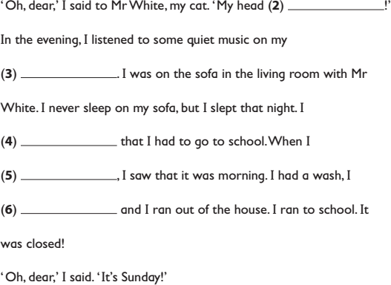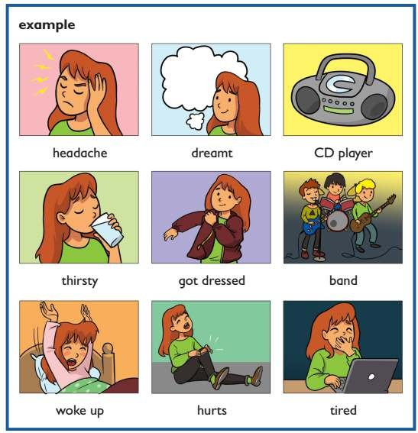

**III/ Read the text and choose the best answer.**

1. **Nick**: Can you see those birds on the rock?

**Paul**: A Yes, I can B Me too.

C Yes, that’s right.

1. **Nick**: Paul, are you afraid?

**Paul:** A Yes, you are.

* 1. So do I.
  2. No, I am not.

1. **Nick**: Do you think these birds are very big?

**Paul**: A No, I can’t see them.

B No, they aren’t. C Yes, they were.

1. **Nick**: Paul, is that your towel on the sand?

**Paul**: A No, it’s not mine.

1. Yes, it’s their.
2. No, these are yours.
3. **Nick**: I’m hungry. Are you?

**Paul**: A Yesterday. B On Sunday.

C I am very hungry.

1. **Nick**: Well, what did you bring for breakfast?

**Paul**: A It’s my pet parrot, Kim.

1. I thought you brought breakfast.
2. I had an egg and a banana for breakfast.

# IV/ Ad r, ger or er to the word to make comparative adjectives

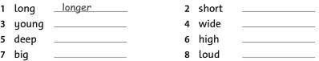

**V/ Underline the correct words.**

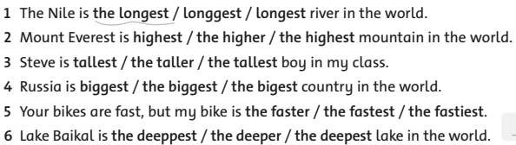

**VI/ Check the correct sentence.**

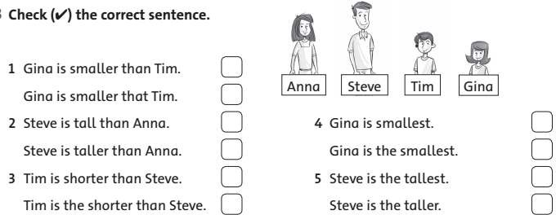

**WRITING**

# I/ Write sentences. Put the adverbs in brackets into the correct place.

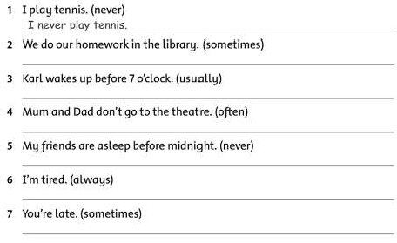

**II/ Write the superlative adjectives.**

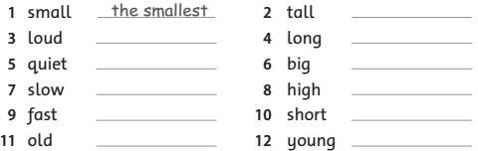

**III/ Look, read and write**

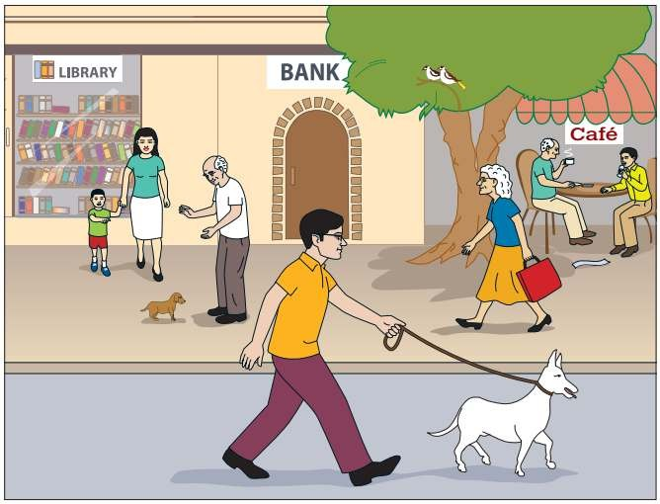

1 The birds are………………………………………………………………..

1. The small boy is holding his mom’s ………………………………………
2. The small dog is brown and the big dog is ………………………………..
3. What is the boy’s mom wearing?

……………………………………………………………………………..

1. What are the old man and young man in the café doing?

………………………………………………………………………………

# IV/ Look and write

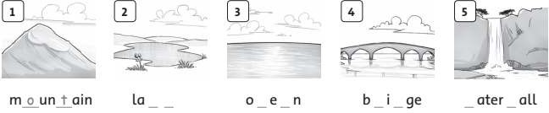

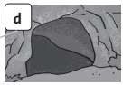

**6**

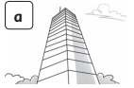

**7**

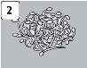

**8**

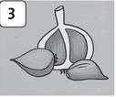

**9**

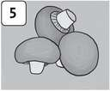

10

a e bu_ _d_ng b_ _n s_r_ _ts _ar_ _c m_sh m